Dataset
rnd_room_c3_02:
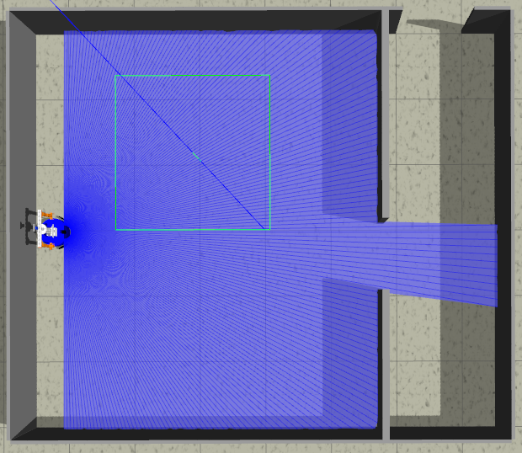
samples
1)
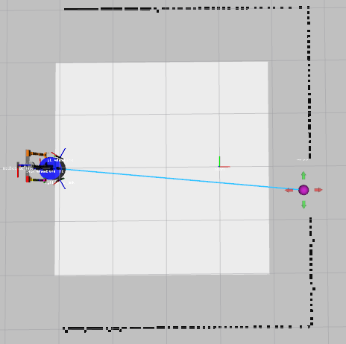
linea recta a puerta 4.7m (x3) (-3.1 0.0 0) to (1.6, -0.4) HEAD tilt: -0.4
files: data_from_path_2025-02-27_14-04-47 to data_from_path_2025-02-27_14-05-39

2)
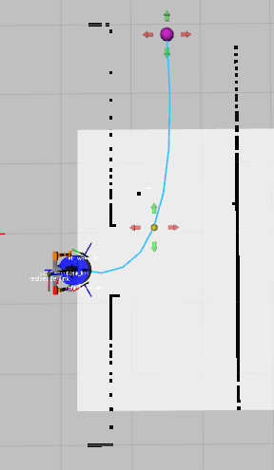
puerta a puerta izq 3.6m (x4) (1.2 -0.5 0) to (2.5, 2.9) HEAD tilt: -0.4
files: data_from_path_2025-02-27_14-11-22 to data_from_path_2025-02-27_14-12-11

3)
puerta a puerta izq 3.6m (x4) (1.2 -0.5 0) to (2.5, 2.9) HEAD tilt: -0.6
files: data_from_path_2025-02-27_14-13-13 to data_from_path_2025-02-27_14-14-01

4)
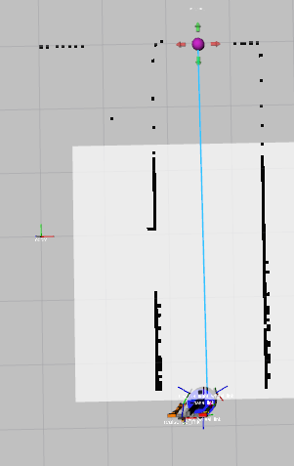
pasillo a puerta (x4) (2.5 -2.6 1.57075) to (2.5, 2.9) HEAD tilt: -0.4
files: data_from_path_2025-02-27_14-21-10 to data_from_path_2025-02-27_14-22-50

5)
pasillo a puerta (x4) (2.5 -2.6 1.57075) to (2.5, 2.9) HEAD tilt: -0.6
files: data_from_path_2025-02-27_14-23-43 to data_from_path_2025-02-27_14-24-34

-----
Mirror
-----
6)
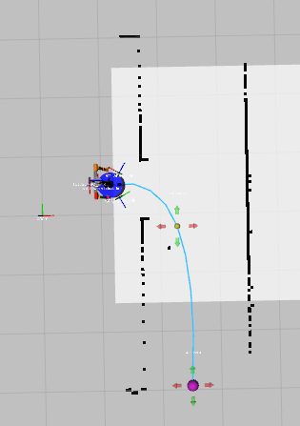
puerta a puerta izq 3.6m (x4) (1.2 0.5 0) to (2.5, -2.9) HEAD tilt: -0.4
files: data_from_path_2025-02-27_14-32-01 to data_from_path_2025-02-27_14-33-03

7)
puerta a puerta izq 3.6m (x4) (1.2 -0.5 0) to (2.5, -2.9) HEAD tilt: -0.6
files: data_from_path_2025-02-27_14-34-32 to data_from_path_2025-02-27_14-35-26

8)
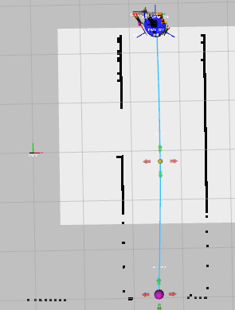
pasillo a puerta (x4) (2.5 2.6 -1.57075) to (2.5, -2.9) HEAD tilt: -0.4
files: data_from_path_2025-02-27_14-38-16 to data_from_path_2025-02-27_14-39-06

9)
pasillo a puerta (x4) (2.5 2.6 -1.57075) to (2.5, -2.9) HEAD tilt: -0.6
files: data_from_path_2025-02-27_14-39-53 to data_from_path_2025-02-27_14-40-50

